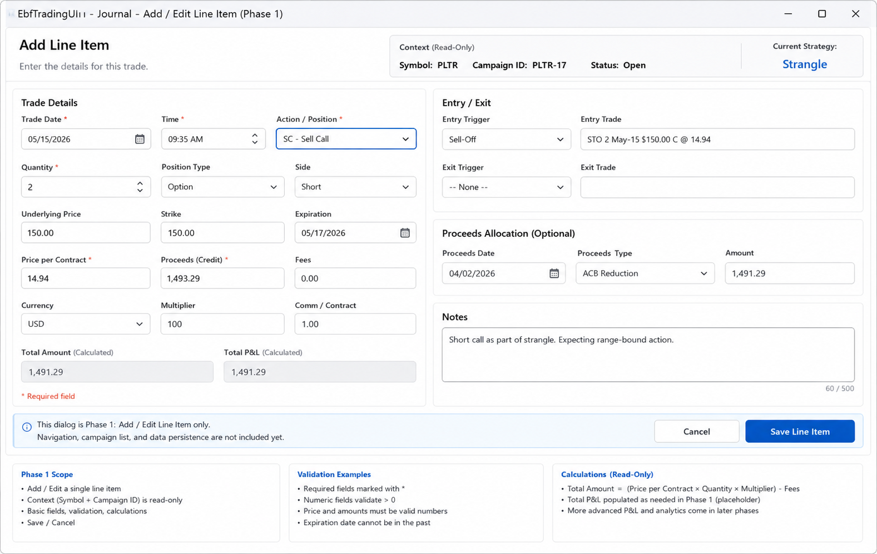
General
- I like the idea of two panels, but lets focus on Trade details panel first
- Labels should not actually have a * to indicate required. Its noisy and validation will handle it.
- Panel 1 should have 4 columns with changes as follows (we’ll address the 2nd panel later):
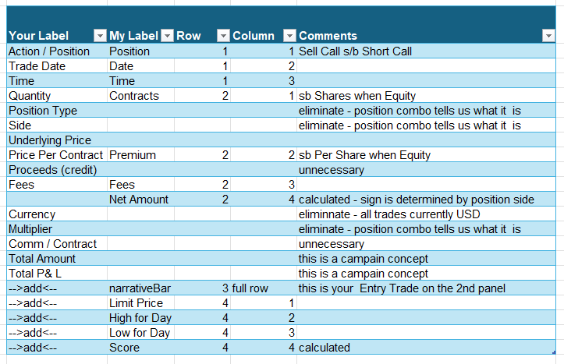

I have a more pragmatic idea. I think we should start this data exercise as a strictly Excel one. The advantages of doing so are:
- You will better understand my actual data and workflow
- I can have tools to improve my current workflow sooner
Biggest Question to resolve first: Opnpxl vs xlWings. My current understanding is that these are the only two choices available

